Vishwakarma Institute’s

Vishwakarma Institute Of Information Technology, PUNE [2019-20]

Project Report on

**Mine Detection Robot**

By

Mr.Darshit Rai(17u481, 422013)

Mr.Harjyot Sethi(17u629, 422019)

Mr.Jigar Sonigara(17u624, 422021)

Mr.Mustafa Jawadwala(17u577, 421037)

Guide

Prof.Yogesh Sharma



Department of Computer Science Engineering

Vishwakarma Institute’s

Vishwakarma Institute Of Information Technology, PUNE [2019-20]



C E R T I F I C A T E

This is certify that

Mr.Darshit Rai(17u481, 422013)

Mr.Harjyot Sethi(17u629, 422019)

Mr.Jigar Sonigara(17u624, 422021)

Mr.Mustafa Jawadwala(17u577, 421037)

Have successfully completed the BE Project entitled Multi-Purpose Mine Detection Robot under my supervision, in the partial fulfillment of Bachelor of Engineering –Computer Science Engineering of Savitribai Phule Pune UniversityAcademic year 2020-21.

Prof.Yogesh Sharma Dr.Sachin Sakhre

Project Guide HOD(Computer Dept.)

Date: 19 /12/2020

Place: Pune External Examiner

**ACKNOWLEDGMENT**

It gives me immense pleasure to express my deepest sense of gratitude and sincere thanks to my respected guide Mr.Yogesh Shama (CS) VIIT, Pune, for his valuable guidance, encouragement and help for completing this work. His useful suggestions for this whole work and co-operative behavior are sincerely acknowledged.

I would like to express my sincere thanks to Dr.Sachin Sakhre HOD(CS) VIIT, Pune, for wholehearted support.

At the end I would like to express my sincere thanks to all my friends and others who helped me directly or indirectly during this project work.

Date:19/12/2020

Place: Pune

Mr.Darshit Rai(17u481, 422013)

Mr.Harjyot Sethi(17u629, 422019)

Mr.Jigar Sonigara(17u624, 422021)

Mr.Mustafa Jawadwala(17u577, 421037)

List of Contents

Acknowledgements……………………………………………………………………………III

Table of content………………………………………………………………………………VII

Abstract……………………………………………………………………………………….XI

Chapters :

1. Introduction………………………………………………………………………….1
   1. History……………………………………………………………………………1
   2. Objective and Scope of Project …………………………………………………1
2. **Literature Review………………………………………………………………….2**

**Abstract**

The main objective behind developing this robot is for surveillance of mines in the field region in order to reduce infiltration from the enemy side. The robot consists of detectors which can transmit detection of the field in order to prevent any damage loss to human life. The robot consists of metal detector and gas detector for the prevention of damage of field.With suitable sensors and cameras to perform different missions, mobile robots are operated remotely for reconnaissance patrol and relay back video images to an operator. Now-a-days android smart phones are the most popular gadget. There are multiple applications on the internet that exploit inbuilt hardware in these mobile phones, such as Bluetooth,GPS technology to control other devices. The proposed system designed a robot that can be controlled using an application running on an android phone. According to commands received from android the robot motion can be controlled. And hence the required actions can be taken.

Keywords- Robot, Camera, GPS(Global Positioning System), Metal detector, Ultrasonic Sensor

**1. Introduction**

**1.1 History**

In this system mine disposal technicians and mission controllers with a number of challenges including high risks in it. A typical mine disposal mission will initially involve investigating the site using a remote controlled robot and disposing the mine. The system also includes detectors which will not only allow viewing whatever will be recorded. The whole system is controlled via android application. An Android smart phone will act as remote controlled device for movement of the robot. An Android application will be developed for the same. The bluetooth module will act as an interface between Smartphone and arduino. bluetooth module will give the commands given by smart phone to the controller. Controller will act as the brain of the robot. The robot movement will be decided by the controller. The Controller will be programmed with the help of the Embedded C programming. In addition to this we also have a ultrasonic sensor and also a metal detector to detect bombs.

**1.2 Objective and Scope of Project**

Now-a-days tracing and attacking enemies at different areas are very much difficult for the soldiers. There is always a chance for loss of lives of the soldiers during war and emergency situations. We are implemented a solution for the problem of replacing a soldier with a Robot Soldier completely controlled with a wireless network. The whole system is controlled via android application. The system sends commands to the receiving circuit mounted on the vehicle through android application. The android application involves commands like forward, backward, right and left direction to control the robotic arm. Each and every movement of the vehicle will be recorded and can be viewed in a PC wirelessly. We can make use of advanced controller in controlling the operation of robot. It can have many uses in practical fields. This system can be helpful in wars as a part of spying. It can be further improved to have more decision taking capabilities by employing varied types of sensors and thus could be used in big industries

**2. Literature Review:**

|  |  |  |  |  |  |
| --- | --- | --- | --- | --- | --- |
| Sr. No. | **Title of the Paper** | **Year of Publication** | **Publisher** | **Methodology** | **Conclusion** |
| 1 | Military function robot | 2017 | PriyankaYadav, LeenaChaudhari, Swati GawhaleBharatiVidyapeeth College of Engineering, Lavale, India | Using night vision camera and monitoring using RFID. | Currently Wireless controlled Omni-directional monitoring robot with video  support that can monitor using webcam.  As per the present scenario, human dependencies on technology and future trends robots are going to be used as a perfect  replacement for human being in all aspects of life. |
| 2 | Arduino Controlled War Field Spy Robot using  Night Vision Wireless Camera and Android  Application | 2015 | Jignesh Patoliya1, Haard Mehta2, Hitesh Patel, V. T. Patel Charotar University of Science and Technology, Changa, Anand, Gujarat,India | Architecture of bluetooth  module HC-05 along with L293D motor driver IC. | The model of robot can be described to build  a robot using night vision wireless camera run by android  application and the people can learn about developing android  application using the platform of MIT app inventor. |
| 2 | Arduino Controlled War Field Spy Robot using  Night Vision Wireless Camera and Android  Application | 2015 | Jignesh Patoliya1, Haard Mehta2, Hitesh Patel, V. T. Patel Charotar University of Science and Technology, Changa, Anand, Gujarat,India | Architecture of bluetooth  module HC-05 along with L293D motor driver IC. | The model of robot can be described to build  a robot using night vision wireless camera run by android  application and the people can learn about developing android |

|  |  |  |  |  |  |
| --- | --- | --- | --- | --- | --- |
| Sr. no. | Title of the paper | Year of publication |  |  |  |
| 3 | Smart Spy Robot | 2016 | Ankit Yadav, AnshulTiwari , Divya Sharma, RatneshSrivastava, Sachin Kumar,  IMS Engineering College, Ghaziabad | Architecture of bluetooth  module HC-05 and RFID technology | The robot will move depending on the motor direction. With the help of the camera we are able to view the things that are happening in the surrounding area where the robot is hidden. |
| 4 | Military Spying and Bomb Disposal Robot Using IOT | 2018 | ChaitraliJadhav, ShamliGibile, SnehalGaikwad, Neelum Dave  DIT, Pimpri | Android phone will connect to the server using TCP/IP link. | Due to the less and rare technology available for bomb disposal operation the demand for wireless technology used for military spying and bomb disposal purpose is very beneficial. |
| 5 | Multi Purpose Military Service Robot | 2017 | E Amareswar, G Shiva Sai Kumar Goud, K R Maheshwari, E Akhil, S Aashraya, T Naveen,  MLR Institute of Technology  Hyderabad, India | An Android smart phone will act as remote controlled device  for movement of the robot. An Android application will be  developed for the same. The application will | This program uses Bluetooth connection to communicate  with robot. It has proven to allow for meaningful two-way  communication between the Android phone and the robot The  Multi-Purpose Military Service Robot has been designed in  such a way that it can fulfill the needs of the military, the  police and armed forces. |

**3. Methodology**

**3.1** Block diagram and its Description

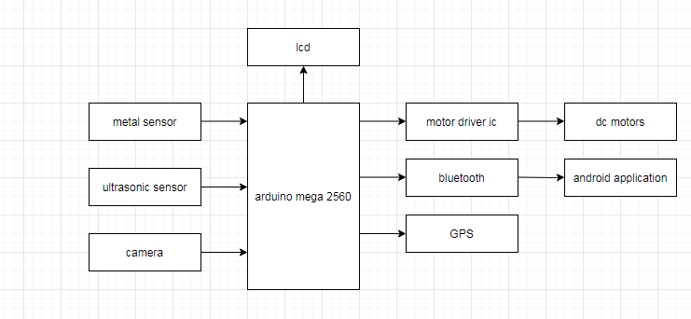

Fig. block diagram of

**Elements of Block Diagram :**

1. Arduino mega 2560
2. Lcd
3. Metal sensor
4. Ultrasonic sensor
5. Camera
6. Motor driver ic L293D
7. Dc motors
8. Bluetooth
9. Gps
10. **Arduino mega 2560:**

* **Arduino Mega** 2560 is a [Microcontroller](https://www.theengineeringprojects.com/2018/03/introduction-to-microcontrollers.html) board based on Atmega2560. It comes with more memory space and I/O pins as compared to other boards available in the market.
* There are 54 digital I/O pins and 16 analog pins incorporated on the board that make this device unique and stand out from others.
* Out of 54 digital I/O, 15 are used for PWM (pulse width modulation).
* A crystal oscillator of 16MHz frequency is added on the board.
* This board comes with USB cable port that is used to connect and transfer code from computer to the board.
* DC power jack is coupled with the board that is used to power the board. Some version of Arduino board lacks this feature like Arduino Pro Mini doesn’t come with DC power jack.
* ICSP header is a remarkable addition to Arduino Mega which is used for programming the Arduino and uploading the code from the computer.

**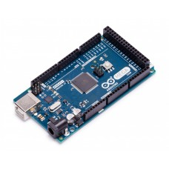**

Fig. 2 Arduino mega 2560 board

* This board comes with two voltage regulator i.e. 5V and 3.3V which provides the flexibility to regulate the voltage as per requirements as compared to Arduino Pro Mini which comes with only one voltage regulator.
* There is no much difference between Arduino Uno and Arduino Mega except later comes with more memory space, bigger size and more I/O pins.
* Arduino software called Arduino IDE is used to program the board which is a common software used for all boards belonged to Arduino family.
* Availability of Atmega16 on the board makes it different than Arduino Pro Mini which uses USB to serial converter to program the board.
* There is a reset button and 4 hardware serial port called USART which produces a maximum speed for setting up communication.
* Following figure shows the specifications of Arduino mega 2560
* **Arduino mega 2560 specifications:**

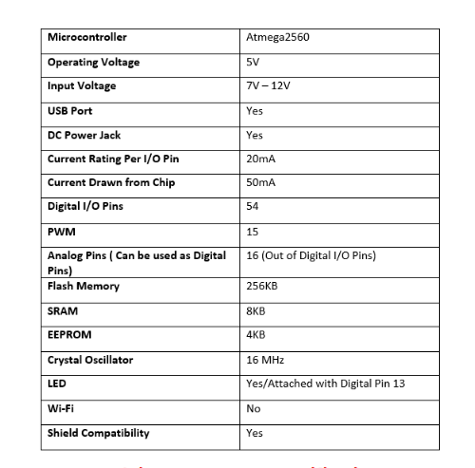

* Arduino Mega is specially designed for the projects requiring complex circuitry and more memory space. Most of the electronic projects can be done pretty well by other boards available in the market which make Arduino Mega uncommon for regular projects. However, there are some projects that are solely done by Arduino Mega like making of 3D printers or controlling more than one motors, because of its ability to store more instructions in the code memory and a number of I/O digital and analog pins.
* There are three ways to power the board. You can either use a USB cable to power the board and transfer code to the board or you can power it up using Vin of the board or through Power jack or batter.
* Last two sources to power the board are required once you already built and compile code into the board through USB cable.
* This board comes with resettable polyfuse that prevents the USB port of your computer from overheating in the presence of high current flowing through the board. Most of the computers come with an ability to protect themselves from such devices, however, the addition of fuse provides an extra layer of protection.
* It can be used either way i.e. for creating stand-alone projects or in combination with other Arduino boards. Most complex projects can be created using this board.
* **Arduino mega 2560 pinout:**

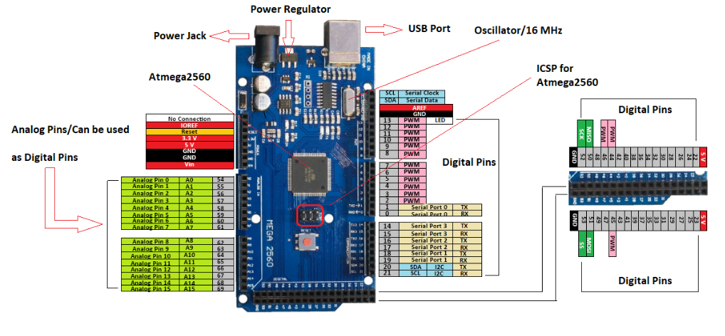

1. **LCD:**

A [liquid crystal display](https://www.edgefxkits.com/wireless-electronic-notice-board-by-gsm-with-user-programable-number-features) or LCD draws its definition from its name itself. It is combination of two states of matter, the solid and the liquid. LCD uses a liquid crystal to produce a visible image. Liquid crystal displays are super-thin technology display screen that are generally used in laptop computer screen, TVs, cell phones and portable video games. LCD’s technologies allow displays to be much thinner when compared to cathode ray tube (CRT) technology.

Liquid crystal display is composed of several layers which include two polarized panel filters and electrodes. LCD technology is used for displaying the image in notebook or some other electronic devices like mini computers. Light is projected from a lens on a layer of liquid crystal. This combination of colored light with the grayscale image of the crystal (formed as electric current flows through the crystal) forms the colored image. This image is then displayed on the screen.

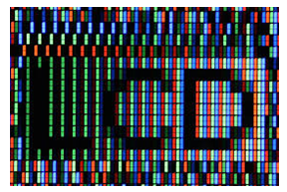

Fig.An lcd

An LCD is either made up of an active matrix display grid or a passive display grid. Most of the Smartphone’s with LCD display technology uses active matrix display, but some of the older displays still make use of the passive display grid designs. Most of the electronic devices mainly depend on liquid crystal display technology for their display. The liquid has a unique advantage of having low power consumption than the LED or cathode ray tube.

Liquid crystal display screen works on the principle of blocking light rather than emitting light. LCD’s requires backlight as they do not emits light by them. We always use devices which are made up of LCD’s displays which are replacing the use of cathode ray tube.  Cathode ray tube draws more power compared to LCD’s and are also heavier and bigger.

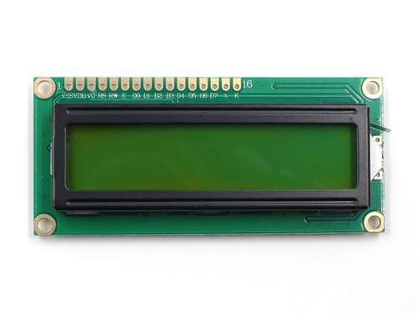

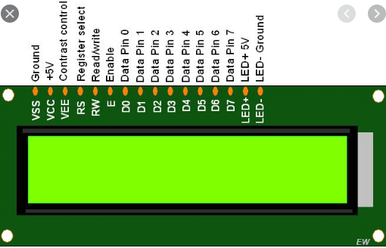

Fig. lcd pinout

**Advantages of an LCD’s:**

* LCD’s consumes less amount of power compared to CRT and LED
* LCD’s are consist of some microwatts for display in comparison to some mill watts for LED’s
* LCDs are of low cost
* Provides excellent contrast
* LCD’s are thinner and lighter when compared to cathode ray tube and LED

**Disadvantages of an LCD’s:**

* Require additional light sources
* Range of temperature is limited for operation
* Low reliability
* Speed is very low
* LCD’s need an AC drive

1. **Metal Sensor:**

It is use to detect metal object and send message to the controller. It is specially used for bomb detectionFully automatic self-adjusting circuit. Effectively detects minute quantities of gold, silver, platinum, brass, copper, mild & stainless steel. Ultra-high sensitivity and stability. Large scanning area. Very quick & clear response to metal objects. Visual indications for Power ON, Metal detection, Battery Low & Battery charging ON. Proportional Variable Audio gives an idea of quantity of metal detected. Does not affect cardiac pacemaker & magnetic tapes. ABS mounded body provides high strength, ruggedness and light in weight. Operates on disposable dry battery or on rechargeable battery. In-built battery charger.

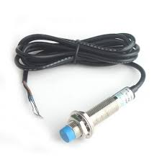

Fig 3. Metal sensor

1. **Ultrasonic Sensor :**

It is used to calculate the distance between the object and robot

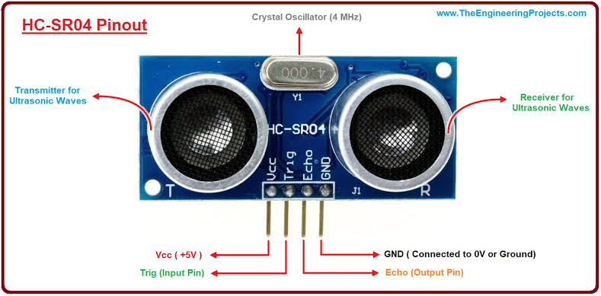

Fig.4 **Ultrasonic Sensor**

An ultrasonic sensor is an instrument that measures the distance to an object using ultrasonic sound waves. An ultrasonic sensor uses a transducer to send and receive ultrasonic pulses that relay back information about an object’s proximity. High-frequency sound waves reflect from boundaries to produce distinct echo patterns. Ultrasonic sensors work by sending out a sound wave at a frequency above the range of human hearing.  The transducer of the sensor acts as a microphone to receive and send the ultrasonic sound. Our [ultrasonic sensors](https://www.maxbotix.com/SelectionGuide/Selection-Guide.htm), like many others, use a single transducer to send a pulse and to receive the echo.  The sensor determines the distance to a target by measuring time lapses between the sending and receiving of the ultrasonic pulse.The working principle of this module is simple.  It sends an ultrasonic pulse out at 40kHz which travels through the air and if there is an obstacle or object, it will bounce back to the sensor. By calculating the travel time and the speed of sound, the distance can be calculated. It can be detect the obstractions.

**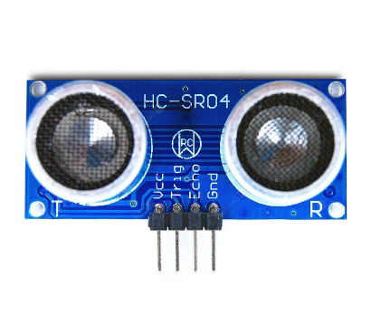**

Ultrasonic sensors are used primarily as [proximity sensors](https://www.fierceelectronics.com/sensors/what-a-proximity-sensor). They can be found in automobile self-parking technology and anti-collision safety systems. Ultrasonic sensors are also used in robotic obstacle detection systems, as well as manufacturing technology. [In comparison to infrared (IR) sensors](https://www.maxbotix.com/articles/ultrasonic-or-infrared-sensors.htm) in proximity sensing applications, ultrasonic sensors are not as susceptible to interference of smoke, gas, and other airborne particles (though the physical components are still affected by variables such as heat).

Ultrasonic sensors are also used as [level sensors](https://www.fierceelectronics.com/sensors/what-a-level-sensor) to detect, monitor, and regulate liquid levels in closed containers (such as vats in chemical factories). Most notably, ultrasonic technology has enabled the medical industry to produce images of internal organs, identify tumors, and ensure the health of babies in the womb.

**6) Motor driver IC L293D:**

* L293D is a typical Motor driver or Motor Driver IC which allows DC motor to drive on either direction. L293D is a 16-pin IC which can control a set of two DC motors simultaneously in any direction. It means that you can control two [DC motor](https://www.rakeshmondal.info/High-Torque-Motor-Low-RPM-Motor) with a single L293D IC. Dual H-bridge Motor Driver integrated circuit *(*IC*).*
* The l293d can drive small and quiet big motors as well, check the Voltage Specification at the end of this page for more info.
* You can Buy L293D IC in any electronic shop very easily and it costs around 70 Rupees (INR) or around 1 $ Dollar (approx Cost) or even lesser cost. You can find the necessary pin diagram, working, a circuit diagram, Logic description and Project as you read through.

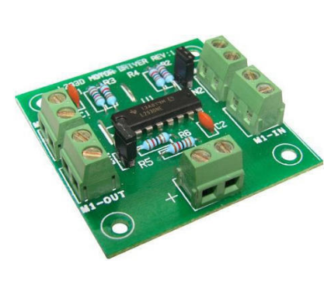

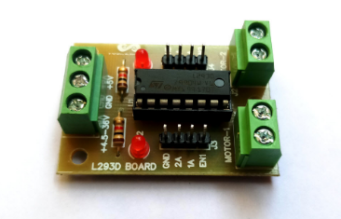

* L293D Pin diagram:

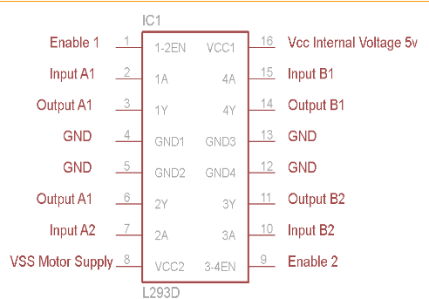

* **Working concept:**

1. It works on the concept of H-bridge. H-bridge is a circuit which allows the voltage to be flown in either direction. As you know voltage need to change its direction for being able to rotate the motor in clockwise or anticlockwise direction, Hence H-bridge IC are ideal for driving a DC motor.
2. In a single L293D chip there are two h-Bridge circuit inside the IC which can rotate two dc motor independently. Due its size it is very much used in robotic application for controlling DC motors. Given below is the pin diagram of a L293D motor controller.
3. There are two Enable pins on l293d. Pin 1 and pin 9, for being able to drive the motor, the pin 1 and 9 need to be high. For driving the motor with left H-bridge you need to enable pin 1 to high. And for right H-Bridge you need to make the pin 9 to high. If anyone of the either pin1 or pin9 goes low then the motor in the corresponding section will suspend working. It’s like a switch.

**7) DC motor:**

**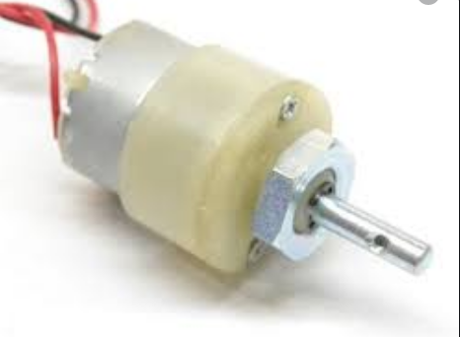**

**Fig.dc motor**

A [DC motor is an electric motor](https://www.edgefxkits.com/speed-control-unit-designed-for-a-dc-motor) that runs on direct current power. In any electric motor, operation is dependent upon simple electromagnetism. A current carrying conductor generates a magnetic field, when this is then placed in an external magnetic field, it will encounter a force proportional to the current in the conductor and to the strength of the external magnetic field.It is a device which converts electrical energy to mechanical energy. It works on the fact that a current carrying conductor placed in a magnetic field experiences a force which causes it to rotate with respect to its original position.

Practical DC Motor consists of field windings to provide the magnetic flux and armature which acts as the conductor.

**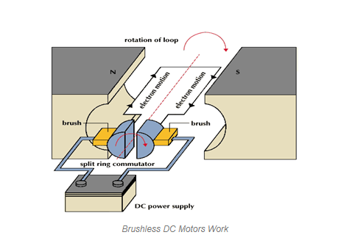**

The input of [a brushless DC motor](https://www.edgefxkits.com/closed-loop-control-for-a-brushless-dc-motor-to-run-at-the-exactly-entered-speed) is current/voltage and its output is torque. Understanding the operation of DC motor is very simple from a basic diagram is shown in below. DC motor basically consist two main parts. The rotating part is called the rotor and the stationary part is also called the stator. The rotor rotates with respect to the stator.

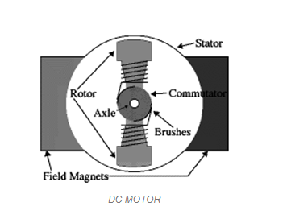

The rotor consists of windings, the windings being electrically associated with the commutator. The geometry of the brushes, commutator contacts and rotor windings are such that when power is applied, the polarities of the energized winding and the stator magnets are misaligned and the rotor will turn until it is very nearly straightened with the stator’s field magnets.

As the rotor reaches alignment, the brushes move to the next commutator contacts and energize the next winding. The rotation reverses the direction of current through the rotor winding, prompting a flip of the rotor’s magnetic field, driving it to keep rotating.

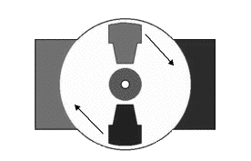

### Advantages of DC Motor:

1. Provide excellent speed control for acceleration and deceleration
2. Easy to understand design
3. Simple, cheap drive design

**8) Bluetooth:**

**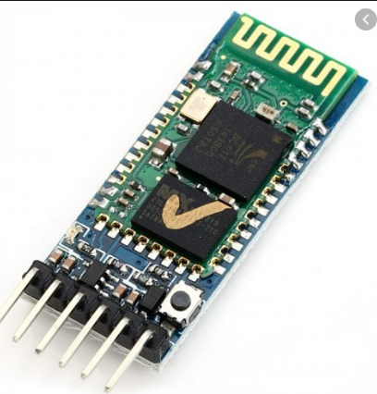**

**Fig: Bluetooth module HC05**

**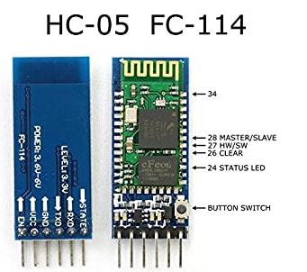**

**Fig: Bluetooth module pin description**

* it is used for many applications like wireless headset, game controllers, wireless mouse, wireless keyboard and many more consumer applications.
* It has range up to <100m which depends upon transmitter and receiver, atmosphere, geographic & urban conditions.
* It is IEEE 802.15.1 standardized protocol, through which one can build wireless Personal Area Network ([PAN](https://en.wikipedia.org/wiki/Personal_area_network)). It uses frequency-hopping spread spectrum ([FHSS](https://en.wikipedia.org/wiki/Frequency-hopping_spread_spectrum)) radio technology to send data over air.
* It uses serial communication to communicate with devices. It communicates with microcontroller using serial port (USART).

# ****HC-05 Bluetooth Module****

* HC-05 is a Bluetooth module which is designed for wireless comunication. This module can be used in a master or slave configuration.

Pin description:

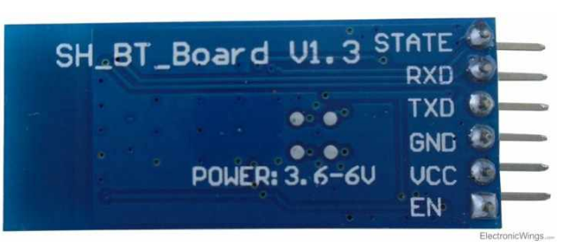

Bluetooth serial modules allow all serial enabled devices to communicate with each other using Bluetooth.

It has 6 pins,

1.  **Key/EN:** It is used to bring Bluetooth module in AT commands mode. If Key/EN pin is set to high, then this module will work in command mode. Otherwise by default it is in data mode. The default baud rate of HC-05 in command mode is 38400bps and 9600 in data mode.

HC-05 module has two modes,

         1.  **Data mode:**Exchange of data between devices.

         2.  **Command mode:**It uses AT commands which are used to change setting of HC-05. To send these commands to module serial (USART) port is used.

2.  **VCC:**Connect 5 V or 3.3 V to this Pin.

3.  **GND:**Ground Pin of module.

4.  **TXD:**Transmit Serial data (wirelessly received data by Bluetooth module transmitted out serially on TXD pin)

5.  **RXD:** Receive data serially (received data will be transmitted wirelessly by Bluetooth module).

6.  **State:**It tells whether module is connected or not.

**HC-05 module Information**

* HC-05 has red LED which indicates connection status, whether the Bluetooth is connected or not. Before connecting to HC-05 module this red LED blinks continuously in a periodic manner. When it gets connected to any other Bluetooth device, its blinking slows down to two seconds.
* This module works on 3.3 V. We can connect 5V supply voltage as well since the module has on board 5 to 3.3 V regulator.
* As HC-05 Bluetooth module has 3.3 V level for RX/TX and microcontroller can detect 3.3 V level, so, no need to shift transmit level of HC-05 module. But we need to shift the transmit voltage level from microcontroller to RX of HC-05 module.

# **Bluetooth communication between Devices**

E.g. Send data from Smartphone terminal to HC-05 Bluetooth module and see this data on PC serial terminal and vice versa.

To communicate smartphone with HC-05 Bluetooth module, smartphone requires Bluetooth terminal application for transmitting and receiving data. You can find Bluetooth terminal applications for android and windows in respective app. store.

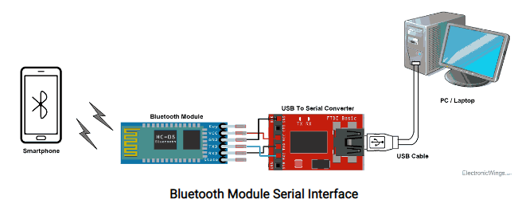

So, when we want to communicate through smartphone with HC-05 Bluetooth module, connect this HC-05 module to the PC via serial to USB converter.

Before establishing communication between two Bluetooth devices, 1st we need to pair HC-05 module to smartphone for communication.

**Pair HC-05 and smartphone**:

1. Search for new Bluetooth device from your phone. You will find Bluetooth device with “HC-05” name.
2. Click on connect/pair device option; default pin for HC-05 is 1234 or 0000.

After pairing two Bluetooth devices, open terminal software (e.g. Teraterm, Realterm etc.) in PC, and select the port where we have connected USB to serial module. Also select default baud rate of 9600 bps.

In smart phone, open Bluetooth terminal application and connect to paired device HC-05.

It is simple to communicate, we just have to type in the Bluetooth terminal application of smartphone. Characters will get sent wirelessly to Bluetooth module HC-05. HC-05 will automatically transmit it serially to the PC, which will appear on terminal. Same way we can send data from PC to smartphone.

# **Command Mode**

* When we want to change settings of HC-05 Bluetooth module like change password for connection, baud rate, Bluetooth device’s name etc.
* To do this, HC-05 has AT commands.
* To use HC-05 Bluetooth module in AT command mode, connect “Key” pin to High (VCC).
* Default Baud rate of HC-05 in command mode is 38400bps.
* Following are some AT command generally used to change setting of Bluetooth module.
* To send these commands, we have to connect HC-05 Bluetooth module to the PC via serial to USB converter and transmit these command through serial terminal of PC

**9) GPS :**

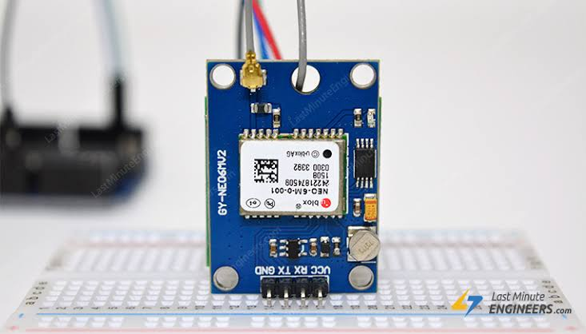

Fig.6 GPS

GPS receivers are generally used in smartphones, fleet management system, military etc. for tracking or finding location.Global Positioning System (GPS) is a satellite-based system that uses satellites and ground stations to measure and compute its position on Earth.GPS is also known as Navigation System with Time and Ranging (NAVSTAR) GPS.GPS receiver needs to receive data from at least 4 satellites for accuracy purpose. GPS receiver does not transmit any information to the satellites.This GPS receiver is used in many applications like smartphones, Cabs, Fleet management etc.GPS receiver uses a constellation of satellites and ground stations to calculate accurate location wherever it is located. These GPS satellites transmit information signal over radio frequency (1.1 to 1.5 GHz) to the receiver. With the help of this received information, a ground station or GPS module can compute its position and time.GPS receiver receives information signals from GPS satellites and calculates its distance from satellites. This is done by measuring the time required for the signal to travel from satellite to the receiver.

## 4.Hardware Implementation

## 4.1 CircuitDiagram

### C:\Users\PRITI\Pictures\arduino lcd.jpg

### Fig,11Arduino interfacing with LCD and ultrasonic sensor

### C:\Users\user\Desktop\20191012_104108.jpg

### Fig: results of ultrasonic sensor and lcd testing

### 5.Software Implementation:

1. Programming software: Arduino

The Arduino Integrated Development Environment - or Arduino Software (IDE) - contains a text editor for writing code, a message area, a text console, a toolbar with buttons for common functions and a series of menus. It connects to the Arduino and Genuine hardware to upload programs and communicate with them.

1. Simulation software: Proteus

The Proteus Design Suite is a Proprietary software tool suite used primarily for electronic. Design automation. The software is used mainly by electronic design engineers and technicians to create schematics and electronics prints for manufacturing printed circuit boards. The Proteus Design Suite is a Windows application for schematic capture, simulation, and PCB layout design.

**Features:**

· Real-time data across an organization or enterprise from underlying sources.

· Extremely secure with full user and database security layers.

· One source for editing, analysis and verification of data from multiple sources.

· Extends functionality of underlying application.

1. PCB designing software: Express PCB

**6. Advantages &Applications**

**6.1) Advantage**

1) The robot is small so can be used for detecting.

2) Robots are autonomous or remote-controlled devices or robots designed for military applications.

3) Robots could reduce the number of military personnel injured or killed in combat situations.

### 

### 6.2) Application

1) It can be used for search & rescue type operations.

2*)* In bomb detection.

3) This robot can be used in the borders for detection of hidden land mines.

## 7.Conclusion

Smart phone is android which can develop effective remote control program. At the same time, this program uses Bluetooth connection to communicate with robot. It has proven to allow for meaningful two-way communication between the Android phone and the robot The Multi-Purpose Military Service Robot will be designing in such a way that it can fulfill the needs of the military, the police and armed forces. It has countless applications and can be used in different environments and scenarios. For instance, at one place it can be used by the armed forces, military purposes, while at another instance it can be used for spy purposes. It will also be able to diffuse the mines after detecting it.

**8. Results:**

**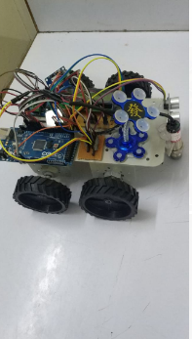**

**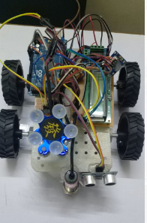**

****

## References

### Journal /Article /Paper

[1]War Field Spying Robot with Wireless Night VisionCameraInternational Journal for Research in Applied Science & Engineering Technology ISSN: 2321-9653; IC Value: 45.98; SJ Impact Factor :6.887

Volume 5 Issue XII December 2017

Author:PriyankaYadav, LeenaChaudhari, Swati GawhaleBharatiVidyapeeth College of Engineering, Lavale, India.

[2] Arduino Controlled War Field Spy Robot using Night Vision Wireless Camera and Android Application Conference Paper · November 2015DOI:10.1109/NUICONE.2015.7449624

Author:Jignesh Patoliya1, Haard Mehta2, Hitesh Patel, V. T. Patel Charotar University of Science and Technology, Changa, Anand, Gujarat,India.

[3] Smart Spy Robot ISSN: 2278 – 7798 International Journal of Science, Engineering and Technology Research Volume 5, Issue 4, April 2016 973 All Rights Reserved © 2016 IJSETR.

Author: AnkitYadav, AnshulTiwari ,Divya Sharma, RatneshSrivastava, Sachin Kumar,

IMS Engineering College, Ghaziabad

[4] Military Spying and Bomb Disposal Robot Using IOT. International Research Journal of Engineering and Technology (IRJET) e-ISSN: 2395-0056 Volume: 05 Issue: 04 | Apr-2018 www.irjet.net p-ISSN: 2395-0072.

Author:ChaitraliJadhav, ShamliGibile, SnehalGaikwad, Neelum Dave DIT, Pimpri

[5] Multi Purpose Military Service Robot. International Conference on Electronics, Communication and Aerospace Technology ICECA 2017.

Author:EAmareswar, G Shiva Sai Kumar Goud, K R Maheshwari, E Akhil, S Aashraya, T Naveen,MLR Institute of TechnologyHyderabad, India